- Getting to know each other
- I have no degree, no great accomplishments
- I was schooled by the Holy Spirit during a 13 year period of my life.
- God had me write this down in Angels Believe in You
- Who is James Durham?
- Retired Military Chaplain (active duty for 30 years)
- Pastor outside the military for 13 years
- Degree in psychology and master’s degree in theology
- Author of several books
- 100 Days in Heaven
- James had visitation from angels, visions, and 3rd Heaven visits (where his spirit traveled to where God abides) for 100 consecutive days at God’s request
- Gatekeepers Arise
- Written before Keys to an Open Heaven about the keys every Christian should have in their lives
- Keys to an Open Heaven
- 10 basic concepts elaborating on key aspects of the Christian walk
- What Biblical proof is there of an open heaven?
- How to position ourselves under the open Heaven.
- This allows for: a closer relationship with God where we hear from Him from distinctly, revealing details about our destiny with God (our job here on Earth), outpourings of blessings from Heaven, increased gifts of the Spirit, visitations from angels and visits to the 3rd Heaven among many other things.
- Which are you interested in?
- Most of the group wanted to hear from God more clearly and/or operate in the Gifts of the Spirit more
- Only a couple of people wanted to experience visitations
- Which do you want?
- Why “Keys to an Open Heaven”
- While reading this book, God confirmed this information came directly from Him through 2 miracles
- I asked if it was really necessary to support Israel financially: I was already a member of Christians United for Israel, surely that was enough, “Correct me, God, if I am wrong.”
- Two days later, my blog exploded with activity: I had exactly 10% of my all-time total hits on my blog occur on one day – all from Israel.
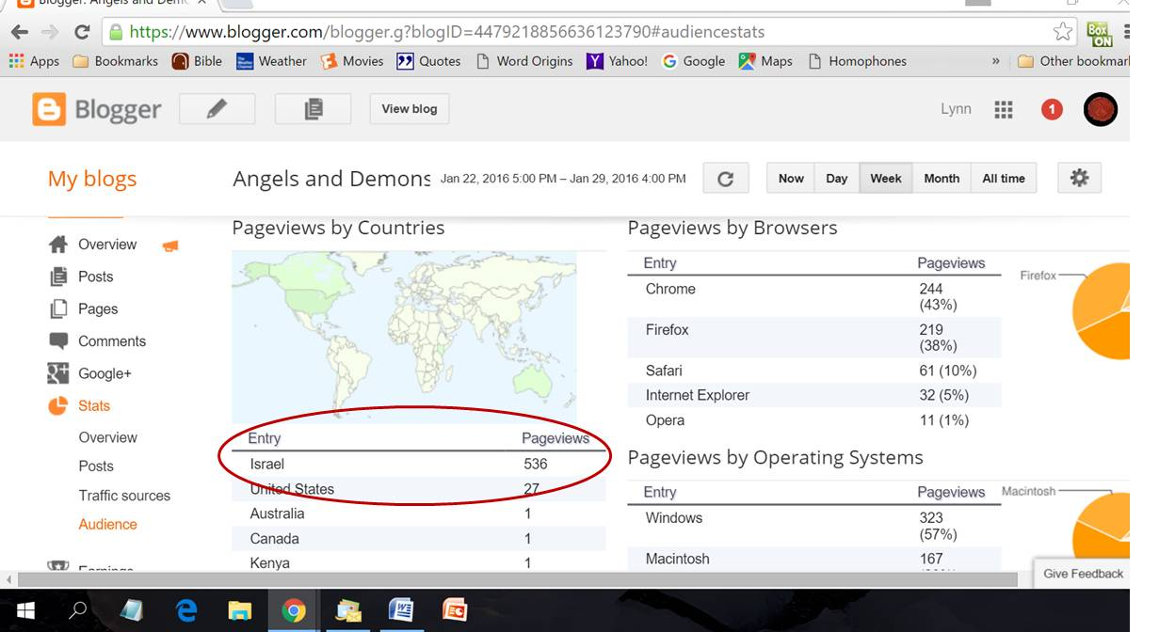
- After reading this book, the last night at the end of my devoted time to God that I set aside to inquire about the direction of my future work for Him I had two dreams. With only 4-5 hours of sleep, I woke instantly from these dreams, full of energy. “Those were some crazy dreams…” not seeing how they could possibly be from God, I asked, “If these are from You, Holy Spirit, you are going to have to show me what they are about.”
- I thought of the items in the dream, starting with the items at the end. Each time I would think of an item, its representation came immediately to my mind. It wasn’t, “well, it might be this” or “it could be that” no it was “It is ______”
- The items fit together perfectly, weaving together a wonderful outline of future events. Each item added layers of meaning to what God has for me to do in the future.
- Preface
- This book was originally written as sermons
- Keep this in mind for it reads like a sermon
- Pastor Durham’s other books do not read like this one
- Five keys every believer should have from Gatekeepers Arise:
- Key to our personal destiny (Isaiah 22:22)
- Key to binding and loosing things according to God’s word (Matthew 16:19); it unlocks our understanding to the principles in God’s word just as Jesus unlocked them for his disciples.
- Key to spiritual discernment. With it we guard our hearts and the hearts of our family members (Luke 17:19-21): it enables us to discern what is holy and good and what we need to shut out. It gives the ability to accomplish this.
- Key to open our hearts to the Father, Son, Holy Spirit.
- Key to death and Hell so that we can draw the lost out of there. (Revelation 1:18, Jude 1:22-23)
- Which of these are you using or have used?
- ________, ________, _______
- Which do you need to the Holy Spirit to help you develop?
- ________, ________, _______
- Next Week: Read Chapters 1 & 2
- Before you begin reading, ask the Holy Spirit to be with you and God to grant you wisdom: “Holy Spirit, my teacher, my guide, be with me as I read this message on your word. Father, grant me wisdom on what I am reading. Show me how it applies to me and my life.”
- The Holy Spirit is our guide.
- ROMANS 8:14 (NKJ) “For as many as are led by the Spirit of God, these are sons of God.”
- JOHN 16:13 NKJ "However, when He, the Spirit of truth, has come, He will guide you”
- The Holy Spirit is our teacher.
- JOHN 14:26 (NKJ) "But the Helper, the Holy Spirit, whom the Father will send in My name, He will teach you all things…”
- God grants us wisdom
- James 1:5 (AMP) “If any of you lacks wisdom [to guide him through a decision or circumstance], he is to ask of [our benevolent] God, who gives to everyone generously and without rebuke or blame, and it will be given to him.”
- Proverbs 2:6-7 (AMP) “For the Lord gives [skillful and godly] wisdom; From His mouth come knowledge and understanding. He stores away sound wisdom for the righteous [those who are in right standing with Him]”

